# Lab Exercises: HTML5 and CSS

Problems for exercises and homework for the [“Software Technologies” course @ SoftUni](https://softuni.bg/courses/software-technologies).

## Welcome to HTML

Create a Web page like at the screenshot:

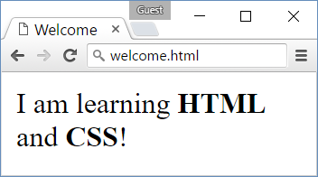

* *File name:* welcome.html
* *Title:* Welcome
* *Paragraph of text:* I am learning **HTML** and **CSS**!

### Hints

Modify the code from the examples in the slides.

## Hello to HTML

Create a Web page like the screenshot:

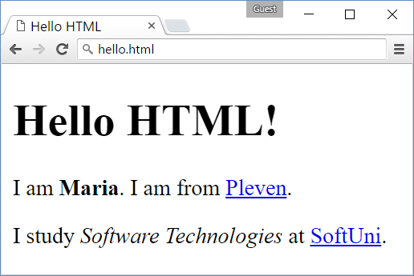

* *File name:* hello.html
* *Title:* Hello HTML
* *Large heading:* Hello HTML!
* *Paragraph of text:* I am <your name (bold)>. I am from <your town as link to your town's Web site>.
* *Paragraph of text:* I study <specialty (italic)> at <link to SoftUni>.

### Hints

Modify the code from the example in the slides.

## My TODO List

Create a Web page like the screenshot:

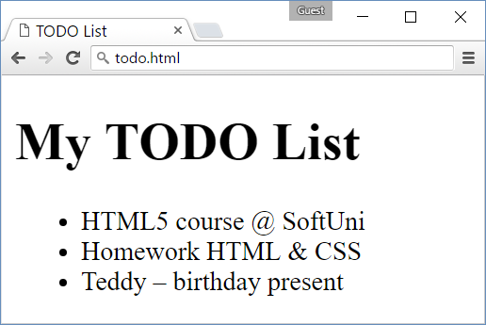

* *File name:* todo.html
* *Title:* TODO List
* *Large heading:* My TODO List
* *Unordered list:* <ul>…</ul>

### Hints

* Create an HTML file named todo.html like in the previous exercises.
* Assign the <title>…<title>.
* Use <ul>…</ul> to create an unordered list.
* Put each of the list items in a <li>…</li> tag.
* Use &endash; for the long hyphen.

## Fruits

Create a Web page like the screenshot:

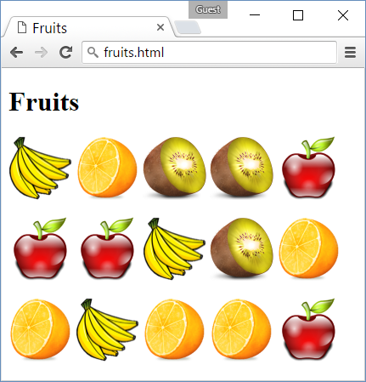

Use the fruit images given in assets:

* images\apple.png
* images\banana.png
* images\kiwi.png
* images\organge.png

### Hints

* Create a HTML page named “**fruits.html**” titled “**Fruits**”.
* Use 3 paragraphs, each holding 5 images.
* Put the images in each paragraph (row) in a sequence, one after another.

## Colors

Create a Web page like the screenshot:

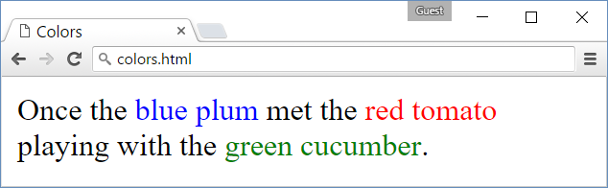

### Hints

* Use a paragraph **<p>…</p>** to hold the text.
* Use <span style="…">text</span> for the colored text

## Rectangles

Create a Web page like the screenshot:

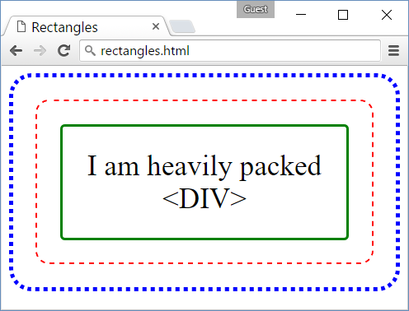

### Hints

* Use 3 nested <div> elements
* **Outside div**: blue dotted border + border-radius + padding
* **Middle div**: red dashed border + border-radius + padding
* **Inner div**: green solid border + border-radius + padding + text-align + font-size
* Use &lt; and &gt; to escape the < and > characters in the text…

## Languages

Create a Web page like the screenshot:

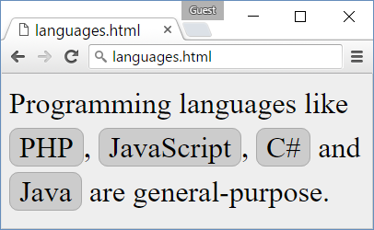

### Hints

* Create HTML file langs.html.
  + Put the text in paragraphs and <span>…</span> tags.
* Create CSS file langs.css.
* Link the CSS file in the HTML header:
  + <link rel="…" href="langs.css">
* In the **body** CSS selector in the CSS class define:
  + background:#EEE; line-height:1.5em; font-size:24pt;
* Define and use a CSS class .lang for styling the languages:
  + Specify border:1px #AAA, border-radius, background:#CCC, padding

## Navigation Icons

Create a Web page like the screenshot:

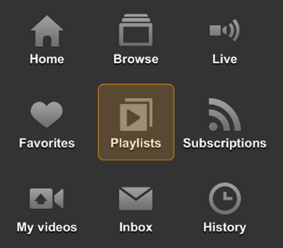

You are given the images for the icons:

* images/home.png
* images/browse.png
* images/live.png
* images/fav.png
* images/playlists.png
* images/subscriptions.png
* images/my-videos.png
* images/inbox.png
* images/history.png

When the mouse is positioned over some of the icons, display the icon with different background and color, like shown at the screenshot above.

### Hints

1. Create the Web page nav-icons.html. Use title “**Icons**”.
2. Create a list of icons: <ul class="icons">…</ul> holding list items <li>…</li> for each icon.
   * In each list item put a link <a href="…">…</a>.
   * In each link put an image <img src="…" /> + <div>…</div> holding the icon text.

A sample code is shown below:

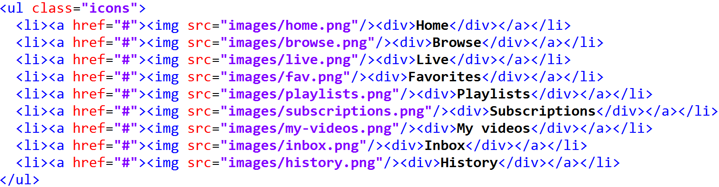

1. Create a CSS file nav-icons.css.
2. Link the CSS from the HTML: <link rel="stylesheet" type="text/css" href="nav-icons.css">
3. Now define the styles for the icons in the CSS file. First, define the size, colors and paddings for the area holding the icons (the dark-brown rectangle area):

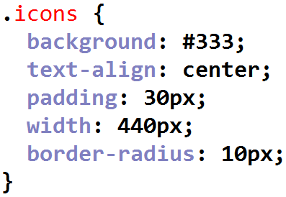

1. Use **inline-block** for the list items. This will position the icons with the text one after another, like in a table with rows and columns:

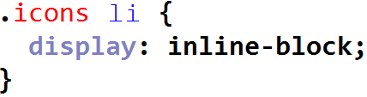

1. Define the **styles for each icon**, when the **mouse is not over** it:

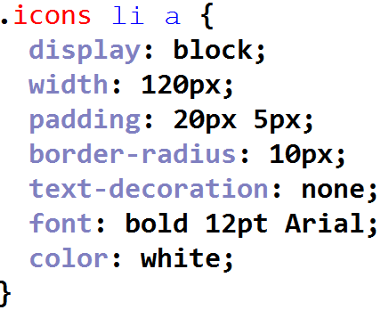

Each icon is a **block** element, with **fixed width**, with some **padding**, border rounding, etc.

1. Define the **styles for each icon**, when the **mouse is over** it:

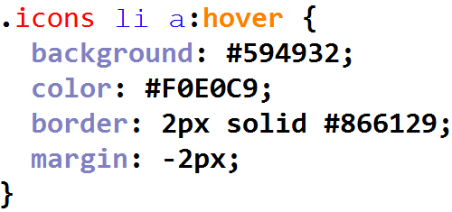

The above CSS styles define a different **background and text color** and adds a **border** around the icon and text. The border will cause a defect: it will increase the width of the box and it will look displaced, so we compensate by adding a **negative margin** of the same width, like the border width.

## Contact Us Form

Create a Web page like the screenshot:

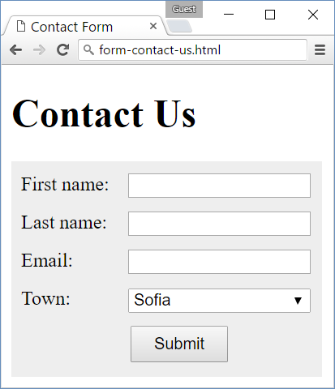

### Hints

1. Create an HTML file contact-us-form.html, put appropriate **title**, put “**Contact Us**” **heading**.
2. Create the **HTML code** to display the form and its fields:

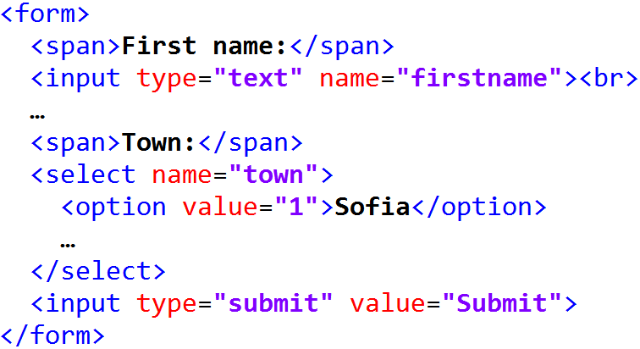

1. In the **CSS file** put some styling to make the for look like at the above screenshot. First define the form background styling:

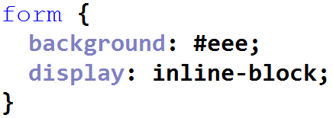

1. Style the **labels** before each form field. They stay in a <span>…</span> tags. Use styling like this:

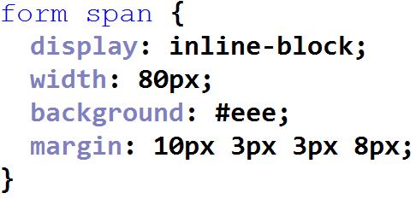

1. Now style the <input>…</input> and <select>…</select> fields:

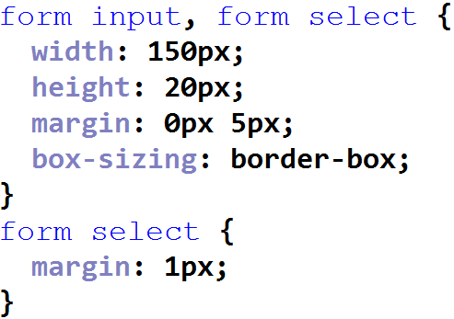

1. Finally, style the “**Submit**” button:

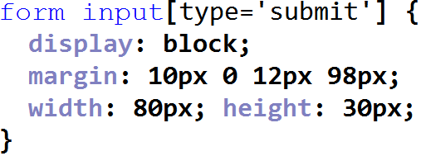

## Floating Elements

This exercise aims to teach you how to **work with floating elements**: left floating, right floating, floating in the middle. The goal is to create a Web page like the screenshot:

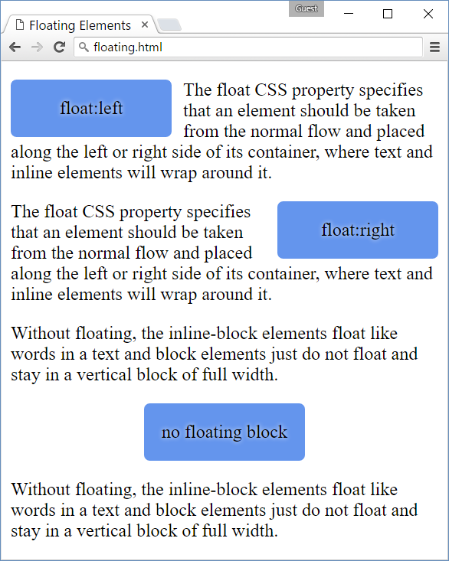

### Hints

1. Create a **HTML page** and put the **text** and floating elements in it. It might look like this:

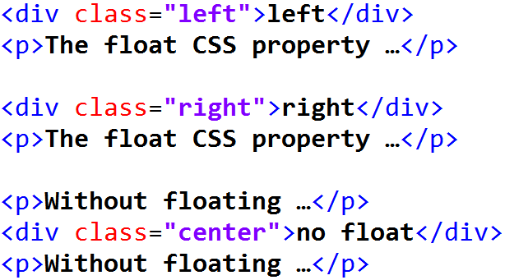

1. Put some **CSS** to position the elements as expected:

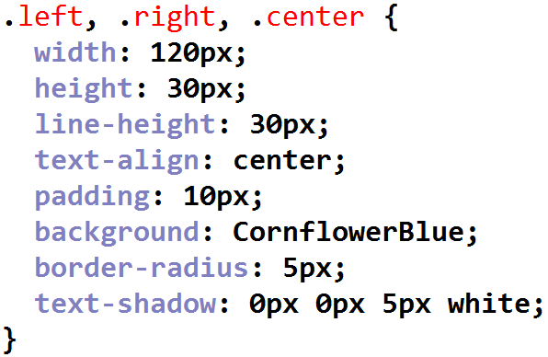 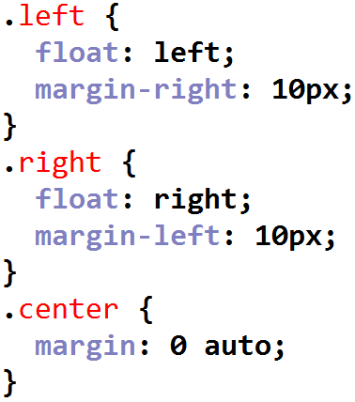

## Very Simple Web Site

Create a Web site like the screenshot:

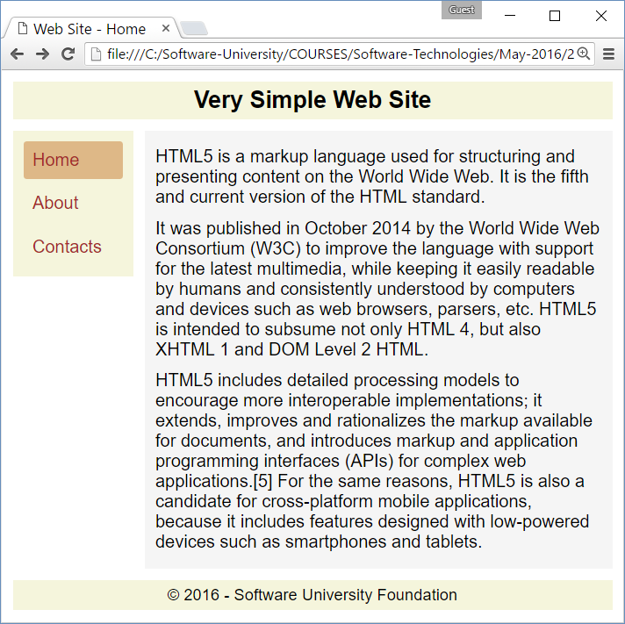

### Hints

…

TODO